

**KAMPALA PARENTS’ SCHOOL 2004**

**P.3 LITERACY 1A NOTES**

**FOR TERM ONE**

**THEME3 ; OUR ENVIRONMENT IN OUR SUB-COUNTY/ DIVISION**

1. Environment are things around us.
2. Another word to mean environment is surroundings.
3. Environment is made up living and non-living things.
4. The study of living and non-living things is called science.

**Examples of living things in our environment.**

1. Animals e.g. insects, birds, cows, goats, fish, frog etc.
2. Plants e.g. trees, grass, mosses, ferns, etc.
3. Fungi e.g. mushrooms, puffballs, toadstools, etc.
4. Bacteria.

**Examples of non-living things in our environment.**

1. Soil.
2. Water.
3. Mountains.
4. Air.
5. Houses.
6. Hills.
7. stone.

**Activity.**

1. What is environment?
2. Give another word to mean environment.
3. What do we call the study of living and non-living things?
4. State any two examples of living things.
5. Apart from fungi, give any other two groups of living things.
6. How do mushrooms reproduce?

**Components of the environment.**

**SOIL**

1. **What is soil?**

Soil is the top layer of the earth’s crust / surface.

1. **How is soil formed?**
2. By weathering (breaking down of rocks into small particles)
3. By decomposition (decaying of organic matter i.e. dead plants, animals, fungi and bacteria)
4. **Components of soil.**

What is soil made of?

1. Air.
2. Water.
3. Humus.
4. Living organisms.
5. Rock particles.
6. Mineral salts.

**Experiment to show that air is a component of soil.**

1. What to do.

* put some soil in a glass container.
* Pour some water into the soil in the glass.

**Illustration.**

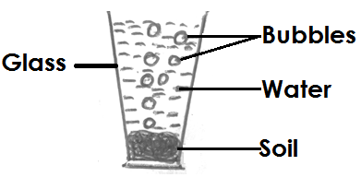

1. **What do you see or observe?**

The air bubbles are seen coming out of the soil.

1. **Conclusion.** Air is a components of soil.

**Experiment to show that water is a component of soil.**

1. **What to do.**

* Put some soil in a saucepan and cover it.
* Put the saucepan on fire and heat it as shown below.

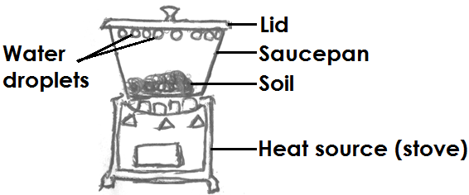

1. What do you see in the above experiment?

Water droplets are seen under the lid.

1. Conclusion: Water is a component of soil.

**Experiment to show that humus is a component of soil.**

1. **What to do.**

* Put soil in a glass jar.
* Pour some water into the jar.
* Shake the jar and let the soil to settle.

**Illustrations.**

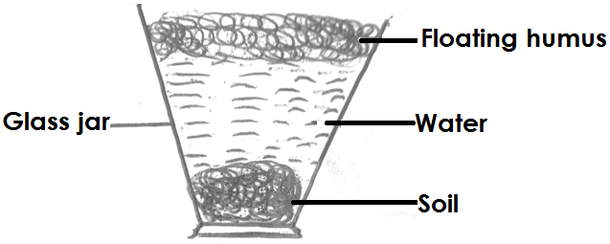

1. **What do you see/ observe in the above experiment?**

Humus floating on water.

1. **Conclusion (what is the experiment all about?)**

Humus is a component of soil.

**NB:** Humus is formed when plants and animals die and decay.

Humus makes the soil soft, dark and fertile.

**Activity.**

1. How is humus formed?
2. Which component of soil makes it fertile?
3. What is soil?
4. State any two components of soil.
5. How is soil formed? (Give two ways)
6. Which component of soil is formed when plants and animals die and decay?
7. How important is humus to the soil?

**Types of soil and soil texture.**

There are mainly three types of soil.

1. Sand soil.
2. Loam soil.
3. Clay soil.

**SOIL TEXTURE**

This is the smoothness or roughness of the soil.

**a) Sand soil.**

* Sand soil has the largest particles and air spaces.
* It is the roughest type of soil.
* Water passes through it easily and faster.
* It is not good for growing cops because it is not fertile.
* It is used for building.

**Arrangement of soil particles in sand soil.**

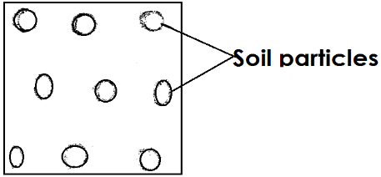

1. **Loam soil.**
2. Loam soil has a lot of humus (It is fertile)
3. It is dark and soft.
4. It is the best soil for growing crops.
5. It is made up of sand, clay and humus.

**Arrangement of soil particles in loam soil.**

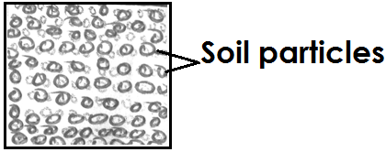

1. **Clay soil.**
2. It has the smallest and smoothest particles.
3. It has the smallest air spaces.
4. Clay soil is sticky.
5. It is the best soil for modeling.
6. It holds water for a long time.

**Arrangement of soil particles in clay soil.**

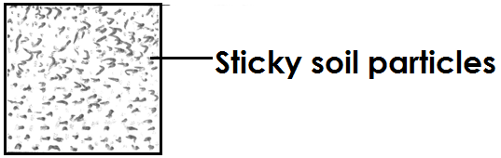

**Activity.**

1. Apart from loam soil, name any two types of soil.
2. Which type of soil is good for growing crops?
3. How important is clay soil to a potter?
4. Name the type of soil marked A, B and C.

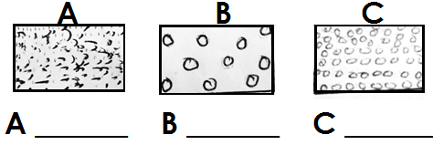

**SOIL PROFILE.**

1. Soil profile is the vertical arrangement of soil layers

**OR**

Soil profile is the arrangement of soil layers from top to bottom.

1. There are mainly three layers of soil i.e. top soil, subsoil layer and parent rock.

**The diagram showing the arrangement of soil layers.**

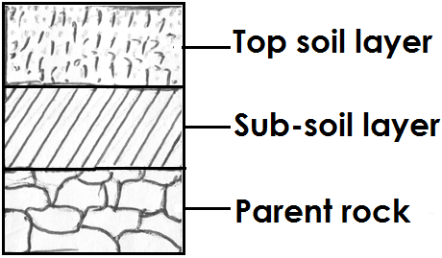

**NB:** Top soil is a layer good for plant growth.

**Uses of soil.**

* For growing crops.
* For building houses.
* For modeling (clay soil) e.g. cups, pots.
* For painting.
* It is a habitat for some living organism such as earth worms, squirrels, rats, wild rabbits etc.
* Soil is used to construct roads, dams and bridges.
* Soil is used to make bricks.
* Soil is used to make blocks.
* Sand soil is used to filter water.
* For washing utensils.

**Activities.**

1. What is soil profile?
2. Which layer of soil is good for plant growth?
3. Name the type of soil good for plant growth.
4. State any two uses of soil.
5. Why is top soil layer good for plant growth?

**Changes in our environment.**

There are two types of changes in the environment.

1. Natural changes.
2. Artificial changes.
3. **Natural changes.**

Natural changes are changes which are not caused or controlled by man.

**Natural causes of changes in the environment.**

* Drought.
* Floods.
* Landslides.
* Earthquakes.
* Hailstones.
* Lightning and thunder.
* Storms / strong wind.

**Drought**

1. A drought is a long period of sunshine without rain.
2. Drought is caused by cutting down trees, burning bushes and draining swamps/ wet lands.

**Activity.**

1. Write down the two types of changes.
2. State three causes of natural changes in our environment.
3. __________________ is a long period of sunshine without rain.
4. How is cutting down of trees dangerous to the environment?

**Effects of natural changes.**

* Drought leads to famine.
* They cause soil erosion.
* They lead to destruction of property.
* They lead to outbreak of diseases.
* They lead to migration of people.

**Soil erosion.**

Soil erosion is the removal (carrying away) of top soil

**Causes of soil erosion.**

1. Deforestation (cutting down of trees)
2. Burning bushes.
3. Over grazing.
4. Over stocking.

**Agents of soil erosion.**

1. Flowing water.
2. Animals.
3. Wind.

**Ways of controlling soil erosion.**

* Planting trees.
* Planting short grass in the school compound.
* By mulching.
* By terracing.

**Activity.**

1. What is soil erosion.
2. Which agent of soil erosion washes away the top soil?
3. State three causes of soil erosion.
4. Write down any two agents of soil erosion.
5. Mention two effects of natural changes in our environment.

**Examples of natural changes in the environment**

-Germination of seeds

-Growth in animals and plants.

-Ripening of fruits.

-Weather changes.

-Rising and setting of the sun.

-Day and night.

1. **Artificial changes.**

These are changes in the environment through human activities.

Artificial changes are changes carried out and controlled by man.

**Human activities that change the environment.**

* Deforestation.
* Burning bushes.
* Over grazing.
* Constructing buildings, roads, dams and bridges.
* Making bricks / brick making.

Draining wetlands / swamps.

- Disposing of wastes.

- Burning bricks.

**Activity.**

1. Suggest four ways of managing changes in the environment.
2. State any two importance of planting trees.

**Possible ways of managing changes in the environment**

1.By afforestation

Afforestation is the planting of trees where there are no trees.

2.By preserving swamps/wetlands.

3.Avoiding bush burning

4.Practicing good farming methods e.g. crop rotation, mulching, terracing etc.

5.Educating people dangers of cutting down trees.

6.Having proper disposal of wastes.

**THEME 4 ; ENVIRONMENT AND WEATHER.**

Weather is the state of atmosphere of a place at a given time.

Aspects / factors / elements of weather.

1. Sunshine.
2. Rainfall.
3. Wind.
4. Temperature.
5. Cloud cover.
6. Humidity.

**Types of weather (conditions).**

1. Sunny weather.
2. Rainy weather
3. Windy weather.
4. Cloudy weather.

**Activity.**

Use the words given in the table below to complete the following scientific sentences.

|  |  |  |  |  |
| --- | --- | --- | --- | --- |
| Cloudy | Weather | Rainfall | Windy | sunny |

1. ______________ is the state of the atmosphere of a place at a given time.
2. When there is a lot sunshine, the weather is ________________.
3. A day can be rainy when there is a lot of _________________.
4. When there is cloud cover, the weather is _______________.

**Changes in seasons.**

1. A season is the same type of weather for a long period of time.
2. **There are two seasons in Uganda.**
3. Dry season.
4. Wet season.
5. **Activities done in the wet season include:**
6. Planting.
7. Weeding.
8. **Activities done in the dry season are:**
9. Harvesting ready crops.
10. Drying harvested crops.

**Activity**

1. How many seasons do we have in Uganda?
2. Write down two seasons in Uganda.
3. Mention two activities carried out by farmers during
4. Wet season.
5. Dry season.
6. Why do farmers harvest their crops during dry season?
7. Why do farmers plant crops in wet season?

**AIR.**

Air is a mixture of gases.

There are four components of air.

1. Oxygen.
2. Nitrogen.
3. Carbon dioxide.
4. Rare gases (Neon, Argon, Xenon, Helium Krypton)

**Percentages of different gases in air.**

* Nitrogen takes up the largest amount of space in the atmosphere.
* Carbon dioxide occupies the smallest amount of space in the atmosphere.

**Illustration.**

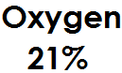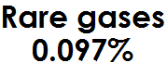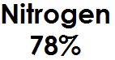

1. Nitrogen gas occupies 78% or 78

100

1. Oxygen gas occupies 21% or 21

100

1. Rare gas occupies 0.97% or 0.97

100

1. Carbon dioxide gas occupies 0.03% or 0.03

100

**Activity.**

1. Which component of air occupies the
2. Largest space in the atmosphere?
3. Least / smallest amount of space in the atmosphere?
4. What is air?
5. Write down any two components of air.
6. Which component of air occupies 0.03% of space in the atmosphere?

**OXYGEN**

1. It is a component of air which supports burning.

Experiment that oxygen supports burning.

1. **What to do:**

* Get a candle, glass jar/ a beaker and a match box.
* Light the candle and place it on the table.
* Lower the beaker gently until it covers the candle as shown below.

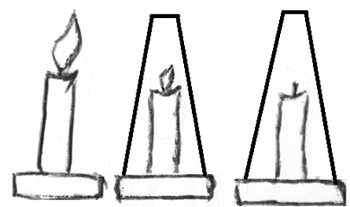

1. **What happens to a burning candle?**

The light on the candle goes off.

1. **Why?**

The glass jar has cut off oxygen supply.

1. **What is your conclusion?**

Oxygen supports burning.

1. Oxygen helps animals in respiration.
2. Seeds need oxygen to germinate.

**CARBONDIOXE.**

1. It’s used by plants for making their own food (photosynthesis)
2. It’s used for putting out fire.
3. Carbon dioxide is used for preserving soft drinks e.g. sodas, beer, wine.

**Activity.**

1. Which component of air supports burning?
2. How important is oxygen in our environment?
3. Why is Carbon dioxide used in fire extinguishing?
4. Which component of air is used for preserving soft drinks?

**WIND (MOVING AIR)**

Wind is moving air. OR Wind is air in motion.

**Importance/ uses of wind.**

* For winnowing.
* For turning /running wind mills.
* For sailing wind powered boats.
* For flying kites.
* For drying clothes.

**Dangers of wind (moving air)**

* Too much wind destroys crops.
* Too much wind destroys houses and other property.
* Wind spread air borne diseases like tuberculosis, flu etc.
* Strong wind at the sea causes drowning.

**Activity.**

1. What is wind?
2. State the difference between wind and air.
3. How important is wind in our environment?
4. Write down any two dangers of wind in the environment.

**Properties of air.**

1. Air has weight.
2. Air occupies space.
3. Air exerts pressure.
4. Air can be compressed.

**What to do:**

1. Get two similar balloons and blow in air of the same amount.
2. Tie their necks tightly such that air does not escape.
3. Balance the two balloons on a beam balance.
4. Prick one of the balloons with a needle.

**Illustrations.**

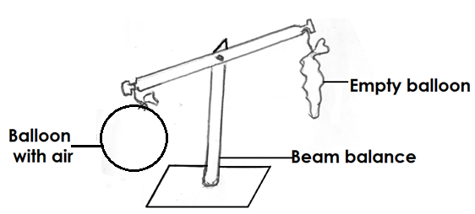

1. What happened after one of the balloons is pricked?
2. The balloon with air moves downwards while empty balloon moves up wards.
3. This shows that air has weight.

**Activity.**

1. Write down four properties of air.
2. Which property of air enables us to drink soda using a straw?

**Experiment to show that air occupies space.**

**What to do (procedure)**

1. Get a glass/cup and a basin full of water.
2. Turn the glass cup up-side down and push it into the water.
3. Tilt the glass/cup to one side.

**Illustrations.**

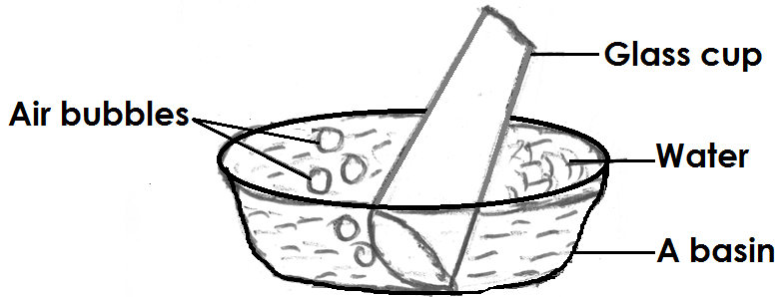

1. **What happens when the glass cup is pushed into the water?**

Air bubbles are seen coming out of water

This shows that air occupies space.

**Experiment to show that air exerts pressure.**

**What to do (procedure).**

1. Get a glass/cup, water and hard paper.
2. Fill the glass with water.
3. Place a hard paper on top of the glass.
4. Turn the glass upside down.

**Illustrations.**

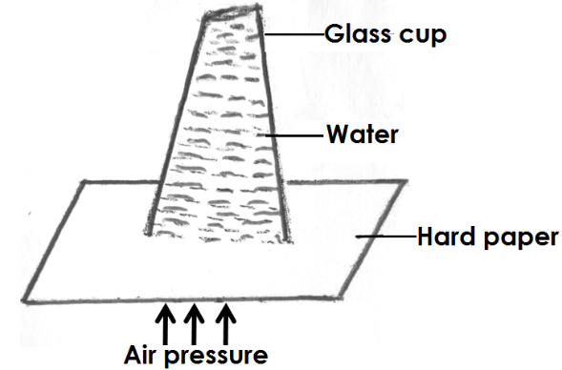

1. **What happens when the glass cup is turned upside down?**

Water does not pour because air pressure exerted outside the glass is equal to the air pressure exerted inside the glass.

This shows that air exerts pressure.

**NB: Other activities which show that air exerts pressure.**

1. Drinking water using a straw.
2. Pumping air into the ball / a bicycle tyre.
3. Sucking medicine using a syringe.
4. Getting water from a tank through a tap.

**Activity.**

1. Draw an experiment to show that;
2. Air occupies space.
3. Air exerts pressure.
4. Write down any two activities carried out to show that air exerts pressure.

**Air can be compressed.**

1. Compressed air can support great weight; vehicles are supported by compressed air in the tyres.
2. Compressed air is used in floaters, balloons, life jackets.
3. Sprays of insecticides and perfumes use compressed air to force the liquid out of the nozzle.
4. A bicycle pump can be used to compress air into tyres, tubes and footballs.

**Experiment to show that air can be compressed.**

What to do (procedure)

1. Get a balloon and a block (brick)
2. Fill the balloon with air and put it on a table.
3. Place a brick on the balloon.

**Illustrations.**

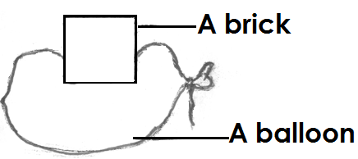

1. What happens to the balloon when a brick is put on it?

The balloon is seen compressing and depressing.

This shows that air can be compressed.

**THE SUN**

1. The sun is the main natural source of light and heat energy.
2. **Uses of the sun.**

* Provides heat for drying harvested crops, clothes etc.
* The sun is a source of solar energy.
* Helps in formation of rainfall by causing evaporation and transpiration.
* Provides light which helps us to see.

1. **Dangers of the sun.**

* Too much sunshine dries crops.
* Too much sunshine causes drought.
* Too much sunshine makes the weather too hot.
* Too much sunshine can kill animals.
* Too much sunshine dries water bodies.

**Activity.**

1. How is the sun useful to us? (Give two ways)
2. Mention two dangers of the sun.
3. What is a drought?
4. Which vitamin is made by our skin with the help of the sun?

**CLOUDS.**

Clouds are masses of water droplets floating in the sky**.**

**There are mainly four types of clouds.**

1. Cirrus clouds.
2. Stratus clouds.
3. Cumulus clouds.
4. Nimbus clouds.

**Stratus clouds.**

* They are nearer to the earth than cumulus clouds.
* They spread in the sky in calm flat layers.
* They are a sign of fine and fair weather.

**Nimbus clouds.**

* They are dark grey clouds.
* They bring rain.
* They are nearest to the earth.
* They do not have any shape.

**Cumulus clouds.**

* They are white like cotton.
* They can develop into thunder storms.
* They are a sign of rainfall.

**Uses of clouds.**

* Clouds help in the formation of rainfall.
* They protect us from direct heat from the sun / sun rays.

**Activity.**

1. Identify any two main types of clouds.
2. Name the highest clouds in the sky.
3. Which clouds bring rain?
4. Give two uses of clouds.

**WATER.**

1. Rain is the main source of water.
2. Other sources of water are; wells, lakes, rivers, sea, springs, dams, oceans, swamps, boreholes, etc.

**Uses of water.**

* For bathing.
* For cooking.
* For washing.
* For watering crops.
* For animals to drink.
* Water supports plant growth.
* Water is used for recreation.
* Water is used as a means of transport.
* Water is used in factories and industries.
* Water is used to generate hydro-electricity.
* Water is a habitat to animals.

**Activity.**

1. Name the main source of water.
2. Mention two other sources of water.
3. How is water useful to us? Give two ways.

**THE WATER CYCLE.**

**Experiment:**

Boil some water in a kettle, put a bottle full of cold water by the spout.

Wrap something around your hand or hold the bottle with tongs. What happens?

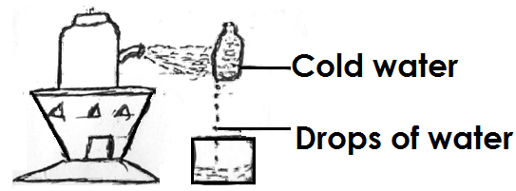

**THE RAIN CYCLE.**

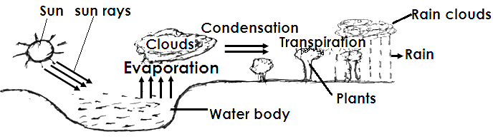

1. When the sun heats the water sources, vapour or steam rises up. This process is called evaporation.
2. Evaporation is the turning of liquid into vapour.
3. Examples of liquids are: water, soda, oil, milk, petrol.
4. Plants lose water in form of water vapour. This is called transpiration.
5. Transpiration is the loss of water from plants through their leaves in form of water vapour.
6. When vapour cools down, it turns into a liquid. This process is condensation.
7. Condensation is the turning of vapour into a liquid on cooling.
8. Rainfall is measured using a rain gauge.

**A DIAGRAM SHOWING A RAINGAUGE.**

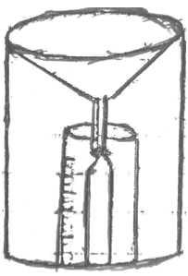

**Dangers of too much rain.**

1. Too much rain spoils crops.
2. Too much rain carries away soil.
3. Too much rain causes floods.
4. Too much rain spoils roads and bridges.

**Activity.**

1. What is the use of the sun in the rain cycle?
2. What is evaporation?
3. Name the process by which plants lose water to the atmosphere.
4. Which instrument is used to measure the amount of rainfall?
5. State one danger of floods.

**Harvesting rain water.**

Rain water from buildings can be trapped and collected in tanks, pots, underground tanks, buckets and saucepans for future use.

**How water sources are made dirty.**

* By throwing or dumping rubbish near or in water sources.
* By bathing or swimming in water sources.
* By urinating or defecating in or near water sources.
* By grazing animals near water sources.
* By allowing animals to drink from water sources.
* By using dirty containers to fetch / draw water from water sources.
* By constructing a latrine near a water source.

**Activity.**

1. State one use of rain water.
2. Name two things we use to harvest water.
3. Mention two dangers of rain.
4. Give two ways how water sources are made dirty.

**Maintenance of water sources.**

Water sources can be kept clean by;

1. Regular cleaning of water sources.
2. Slashing away bushes near water sources.
3. Dumping rubbish far from water sources.
4. Washing clothes far away from water sources.
5. Avoid grazing animals near water sources.
6. Avoid urinating and defecating in water sources
7. Avoid bathing or swimming in water sources.
8. Fencing water sources.
9. Constructing latrines far away from water sources.

**Making water safe for drinking.**

Water from water sources can be made safe for drinking by;

1. Boiling it because it kills germs.
2. Treating it with chemicals.

**How to keep safe water clean.**

Water can be kept clean by;

* Covering it.
* Keeping it in freezers.
* Sealing it.

**How to make dirty water clean.**

* By filtering.
* By decanting.